Radio Program re: (NV) Wild Horse Issues. Wednesdays 11AM- Noon PST.
April 13, 2016 (notes)
To better Understand the Cause
americamatters.us/shows/mustang-matters/
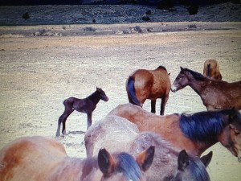
----------
Hosted by,
lacyjdalton.com/ – Country Guitarist and Singer, 775.847.7322 founder of letemrun.com/ & letemrun.org
and
Dee Gregory (rock & roll hall of fame MC) also on behalf of letemrun.org
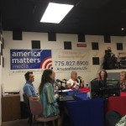
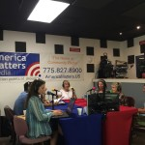
plus regular special guest appearances by
Eddie Floyd, Host, Reporter, P.I.O., Fox News Radio- {NEVADA MATTERS INC. (Founder) -}
as well as Shari Floyd, founder of Wynema Ranch.
---------
Notes by,
haay.org/ - Helping Animals and Yourself
haay.org/news-mustangmatters-us/
---
To audio archive Mustang Matters (alphabetized) radio shows, go to americamatters.us/show-archives/ and
all written briefs see haay.org/news-archived-radio-shows/
--
Call America Matters- Mustang Matters

Contact Us!
- Please call in- Toll-Free Worldwide: 1- 844.790.TALK (8255)
On Air Text: 1- 775-237-2266. Business Office: 1- 775-827-8900
-------
Opening music...—
Dee Gregory introduces
Lacy J Dalton
Emilyn Roberts with Let Em Run & Eddie Floyd for Shari, Pete Dunham and Jared (14.5 yrs-son of Pete) with the Wynema Ranch.
---
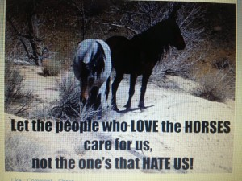
---
see you again next week. Wednesday 11Am- Noon.
WE HOPE YOU HAVE A BEAUTIFUL BLESSED DAY!
please remember:
BLM HORSE AUCTION –
BLM/ CARSON CITY PRISON
https://www.blm.gov/adoptahorse/onlinegallery.php
&
News and voting:
www.wildhorsepreservation.org/
haay.org/news-2/
http://renotahoe.about.com/od/nevadapubliclands/a/wildhorses_
-------
Sponsors:
One stop feed store - http://www.1stopranchandfeed.com/ 760 Glendale Ave, Sparks 775.284.0377; say Hi to Hector and Sarah.
Ranchers Feed & Supply, Lemmon Valley 775.972.7200
Builders
---Eddy Hosted this morning.
Lacy J Dalton
Its been a while and its wonderful to have Eddy here this morning.
We will miss our other host Dee this morning.

(Chatting about show/story)

Great panel we have our regular people and two new people today with us.
(jokes & giggles)
Greeting:
Emmalyn Roberts
John Delaney
two guests from Southern part of England area called new forest
Joe

Welcoming the guests people from England..
talking about the new forest in England which is where the guests are from.

(Story) Lacy singing while telling a story...
where country music came from and how it happened.
The old ballets that came from Britain.

Guest: The new forest is 220sq miles of land and comes with your house.
You can raise donkeys sheep horses.....
1000 head of stock running in that area majority are ponies.
The outside of forest is fenced.. The ponies seem to know when you're going to drift them.. (giggles)
sometimes you get 100 and other times five..
rounding them out to warm them up and brand the young ones but still live in the wild life.

Stallions are not year round 10 stallions a year going for one month.

They like to hangout in the middle of the road and horses don't want to move.
(giggles)
Lacy: (jokes) need a horse parking lot. (giggles)

Lacy: Its not a sanctuary but wonderfully managed like a sanctuary and we promote all over the US we have about 50,000 250,000 acres

Guest: Tourism attracted one million years ago.

If ponies were taken off the forest it would be a jungle.

lacy: Its a short side view here in the USA regarding horses its unfortunate.

New forest has been wild and free 50 main families here are commoners.

The top pine is similar to the Mustangs.

Forest ponies are incredibly clever you feel like they are judging you its scary how intelligent they are.

generic memory

lacy: Sounds fascinating

Do they bond more with human beings than most domestic horses.

(chatting)

We have 5 people that spend all day just checking on animals.
Horses can get themselves into messes and its a wonderful idea

We need to do conservation if we want are kids kids to have horses instead of killing them for other people inconveniences,

Mustangs are a very part of America

Lacy:In 1971 The Act of horses and Burros was passed suppose to be the priority animal and will be causing extinction and our Americans are not looking at this problem..
It is a problem in the USA you can tell by the big size/portion of our food and how much goes to waste..

(Laughing)

Wynema Ranch Report: Looks amazing
the horses looked content the gusts were impressed and the place looks great.

Dee called in :
He missed being in the radio
(giggles)
wanted to say Hello
and welcoming the guests
great sanctuary in England.
Take care and just checking in..

Lacy: It is not a Sanctuary but they certantly do a great job of taking care of it like one.

(Talking more bout ponies) more giggles..

Palomino:We have a baby that is struggling we've had him for 5 days and there's another baby its been tough year with the babies.
Was so hot yesterday barely there but eating and drinking water. w hole under his tail and he has bites on his neck.
His legs are so weak and they're flattening.
Lacy: Mentioned of h=getting her help because It is very important to help the babies up if so important and hard for palomino by herslef.

Emmalyn: Getting (NEW ) sip up sweatshirts online right away black color.775-7425338

Letemrun sweatshirts. They also have Bumper stickers,Cd's, let em run license frame plates.

Eddy: Wynema report it looks great and Sharie still there doing great taking care of horses.
775-7715500

Thank you listeners & Sponsors- see you again next week. Wednesday 11Am- Noon.
------------
THANK YOU again for your for your interest and support for
your Wild Animals and Environment.
---
Notes presented to you by,
haay.org/ - Helping Animals and Yourself (home page).
haay.org/news-mustangmatters-us/
www.haay.org/wanted-adoptfostersponsor/
www.haay.org/mustang-foal-baby-horse-rescuers/
www.haay.org/educational-programs/
haay.org/sciences-careers-alternative-resources/
haay.org/eco-research/
haay.org/adventure-eco-horse-tour/
If anyone has any information or idea please contact www.haay.org at HaayOffice@aol.com or call/text 775.338.6046.

