Radio Program re: (NV) Wild Horse Issues. Wednesdays 11AM- Noon PST.
May 20, 2015 (notes)
americamatters.us/shows/mustang-matters/
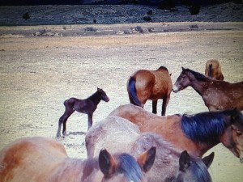
also http://renegaderadio.org/ (Reno, NV) or http://krng.streamon.fm/
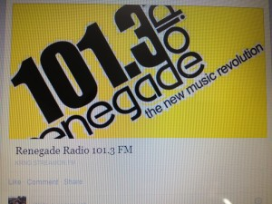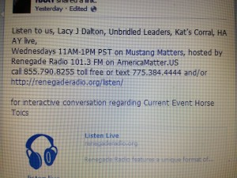
Call 855-790.8255 free or TEXT 775-384-4444 .
Hosted by,
lacyjdalton.com/ – Country Guitarist and Singer, 775.847.7322 founder of letemrun.com/
plus
Eddie Floyd, Host, Reporter, P.I.O., Fox News Radio- {NEVADA MATTERS INC. (Founder) -}
as well as wynemaranch.com/mustang-matters.html
and
also
Dee Gregory (rock & roll hall of fame MC) also on behalf of letemrun.com/
---------
Notes by,
haay.org/ - Helping Animals and Yourself
haay.org/news-mustangmatters-us/
May 20, 2015
---
To audio archive Mustang Matters (alphabetized) radio shows, go to http://americamatters.us/show-archives/ and
all written briefs see haay.org/news-archived-radio-shows/
previous: Haay RR News May 6 2015, Haay RR News April 29 2015, Haay RR News April 22 2015 Haay RR News April 15 2015....
Opening music...--
---
Dee Gregory says hello & announces Lacy J Dalton
844.790. talk (8255).
---
Lacy announces Craig Downer—
Equit Expert for the vanishing Species – author

---
Craig has met with Carol Nicolson (Fine Art Show) spoke at Berkley April 20th for defense of the Wild Horses & spring time speech & showed a film American Mustang – Denise Bobble (sp)
--
Had 41 horse being abused and starved-
Lacy has rescued many from Fallon. Lacy described $40 lbs for baby horse meat over seas.
Lacy comments how public doesn’t know whats going on.
Craig was part of the team that debt with the foal that was hit run on the hwy in Stagecoach, NV.
---
Event:
Jeana from Genoa
Dayton NV- event June 13th
Sunset rotary & let em run
Lacy . Steve Wade – Richard Allion more.
Native American Native American Flute for opening.
Dr. Dave on drums
Pony rides- silent auction
Address. 11Am-
---
Lacy is discussing the horses that may be visiting the event.
Shari says she doesn’t know about her mini horses yet – but Karen Vinies says she will gladly be their babysitter if they are allowed out to the event.
www. Eventbright.com 775.28.57358
---
Craig come share the booth with let em run – sell your book.
---
Evelyn Roberts announces the merchandise: hats, t-shirts, and more plus a silent auction for a day at the Dalton girls bunk house at Wynema.
Silverland hotel, vintage clothing, dinner, lake Tahoe package- Harrah’s, Hunting & Fishing Lodge to Alaska.
---
Carol Nicolson
Brought beautiful metal sculpture for an example. www.facebook.com/nevadamustangfineartshow
Woder 1595 N Sierra Street.
Amazing Art Show. Craig Downer is also honored. 775.843.3900.
Nevadamustangartshow@gmail.com
Tickets available - $25 Donation for VIP ticket -Friday only because Food (Men Welding Fire) goes to Wynema.
Tribute to Lacy is 24th.
One more oil painter & one more water color. Specifically about the mustangs.
Made in NV is store next door. That’s how she met so many wonderful artists.
Ran Rafael Park in Reno.
Robby Sinclair photo of sculpture.
Lacy loves it for the hood of mustang car. Carol says yes, they can be a great hitch cover.
---
Craig is a great Poet, a world class.
--
Caller:
Entertainment & Awareness
Julie Kauffman in Virgina prestigious award on book Seriah’s Legacy screenplay official selection in Film festival- has potential awards for this book.
--
Dee Gregory announces sponsors
James clark
Rogers
---
Julie welcome back after break-
Girl’s voice & need for change
Anna Sowl about 100 years ago, Black Beauty.
--
Seriah came into our life, facing slaughter save her with about 20 in Maryland. I needed to find a voice and help her. The horses eye is the window to the soul. Investors film is being filmed in Stagecoach.
Lacy also says thank you and look forward to the next update.
---
Craig, has a poem to wild horses, extremes of the soul.
He reads---
---
Caller:
Palomino
No Sleep because of four
Mare who lost her baby. Farmington CA- about 5hour trip. Will see if one of them can have a Mommy! Maybe one of them hook up with a mare.
Looking for a segregate?
Mare had a baby and lost the baby. They got a all that someone was looking for an orphan foal.
If she has one that latches on that is the goal!
Meeting council in WA & Humane Society to look into the situation up there.
---
Ranch Report:
Shari
Things are going well. Nothing to report, all is well. Little bit of rain- helped get some green.
Baby who found her way into Shari’s heart, called rose & baby is named petal.
775. 6229.
--
Dee Gregory asks for help for hay/feed, please contact us &/or Wynema.
---
Evelyn talks about all the merchandise for sale, 775.742.5338.
---
June 13th at sunset rotary
Stand up for horses
Carson Chamber tickets June 30th.
Lacy will also be playing at the prison.
Fine art Show
--
Lacy asks Craig how to get a hold of Craig and he tells:
---
Lacy thanks sponsors
--
Rich Cable – The last wild Place.
--
Dee announces sponsors

