Radio Program re: (NV) Wild Horse Issues. Wednesdays 11AM- Noon PST.
June 10, 2015 (notes)
americamatters.us/shows/mustang-matters/
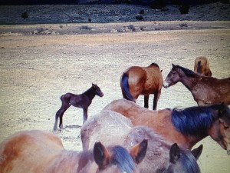
also http://renegaderadio.org/ (Reno, NV) or http://krng.streamon.fm/
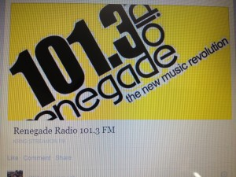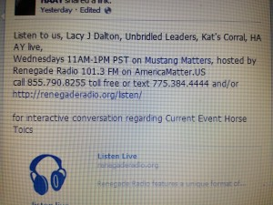
Call 855-790.8255 free or TEXT 775-384-4444 .
Hosted by,
lacyjdalton.com/ – Country Guitarist and Singer, 775.847.7322 founder of letemrun.com/
plus
Eddie Floyd, Host, Reporter, P.I.O., Fox News Radio- {NEVADA MATTERS INC. (Founder) -}
as well as wynemaranch.com/mustang-matters.html
and
also
Dee Gregory (rock & roll hall of fame MC) also on behalf of letemrun.com/
---------
Notes by,
haay.org/ - Helping Animals and Yourself
haay.org/news-mustangmatters-us/
June 10th, 2015
---
To audio archive Mustang Matters (alphabetized) radio shows, go to http://americamatters.us/show-archives/ and
all written briefs see haay.org/news-archived-radio-shows/
previous: Haay RR News May 6 2015, Haay RR News April 29 2015, Haay RR News April 22 2015 Haay RR News April 15 2015....
Opening music...—
Gina June 13th Event
Silent Auction:
Virginia City vacation stay for 8 including vintage clothing
Wheel barrel of wine
Jewelry (stolen from Lacy)
Hand made
Wine tasting for 10 people in Glenbrook
Birthday party for children in Carson
Hand Tied Flies
Sponsors:
Pioneer casino
Carson Hospital
Builders
Horse Trailer Public top
Afflack
Oxygen
Wellness group
Greater NV Credit union
Dr. Todd McFarren

Cover on Virginia City News Paper.
5 Pinecone Road-
11AM start 1PM concert
Proceeds support charities
--
Dayton Health care center –
----
Ronnie –
Historic event in Carson City June 29th – NV State Prison.
---
Julie Keller-
Up to 6AM for the reports for the strieter-lite.com/project. Lacy comments that Julie is a true warrior. Julie mentioned the video’s of she, Eddie Floyd and myself testifying at the Senate.
--
Palomino
Bringing three babies to the Event. Her husband Matt has been fixing up the new horse trailer .
--
Evelyn re: the Dalton Girls Bunkhouse at Wynema Ranch. Near Hallelujah Junction, nestled in the base of the Peterson Mt.’s
--
Riggers Trigger a beautiful Palomino who now
lives out there.
Jim Rigger retired 6years ago, going to be in the color guard and is so honored to do so. The horse looked right into his eyes and Eddie said that is the one for you. Jim bought him and his 8 year old Grandson is so excited.
---
Caller:
Haay.org (Helping Animals And Yourself)-
In passing around Advocacy information, in a meditation group I visit with, a member who works at the Ritz Carlton proposed the idea of Tourism information to pass on to the guests from the Ritz Carlton.
Does anyone want to send me information re: Tours and or other things attractions for the tourist regarding the wild mustangs?
Lacy answered with yes,
the Sunny Boys Wild Horse Tours, http://www.renowildhorsetours.com/ and
The Silver Legacy Resort Casino, Reno NV -Adventure Desk http://www.silverlegacyreno.com/adventure-desk/
Haay.org (Helping Animals And Yourself)- asks, with the prison event coming up/ topic seems to me:
Does the Prison have a program where they can pick up the trash in the Pinenut Mt. Range, home to many of our wild horses; so much of the trash is in & near the little bit of water (their water has human trash in it- be a dry bed of trash left soon too).
Is the only soft flat land I saw Mustang roll too- must have felt good! – I was nervous about all the broken glass, he’s rolling in.
Lacy say’s she thinks this would be the Prison Industries Department- she wasn’t sure.

--
Abby – Vermillion Ohio- love your music cause, and she has met Eddie- listens to America Matters & Mustang Matters- used to be an exercise rider.
Intervention and wants to come out and meet Lacy, Shari, Wynema & Jim Goddard. Wants to tour the shows and
---
Lacy announces if Grandparents are out there and interested to find a horse – kids between 8-12 are perfect ages to start working with horses.
--
Wounded warriors- trail ride for bikers, like a poker run. Near Walker lake.
--
Event this Saturday June 13, Richard Aloin (sp?), for Sunset Rotary of Carson City.
---
Monday, June 29th upcoming concert in historic ground breaking event to turn this into a museum. Dinner & concert almost sold out.
Red old 395 are providing dinner for that event.
6PM concert
Carson Chamber for ticket information
--
Shari Floyd 842-6229
Evelyn 742-5338
-

