Radio Program re: (NV) Wild Horse Issues. Wednesdays 11AM- Noon PST.
July 8, 2015 (notes)
americamatters.us/shows/mustang-matters/
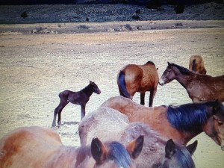
also http://renegaderadio.org/ (Reno, NV) or http://krng.streamon.fm/
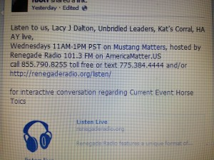
Call 855-790.8255 free or TEXT 775-384-4444 .
Hosted by,
lacyjdalton.com/ – Country Guitarist and Singer, 775.847.7322 founder of letemrun.com/
plus
Eddie Floyd, Host, Reporter, P.I.O., Fox News Radio- {NEVADA MATTERS INC. (Founder) -}
as well as wynemaranch.com/mustang-matters.html
and
also
Dee Gregory (rock & roll hall of fame MC) also on behalf of letemrun.com/
---------
Notes by,
haay.org/ - Helping Animals and Yourself
haay.org/news-mustangmatters-us/
July 8th , 2015
---
To audio archive Mustang Matters (alphabetized) radio shows, go to http://americamatters.us/show-archives/ and
all written briefs see haay.org/news-archived-radio-shows/
previous: Haay RR News May 6 2015, Haay RR News April 29 2015, Haay RR News April 22 2015 Haay RR News April 15 2015....
Opening music...—
--
Dee Gregory introduces Lacy J Dalton
Lacy J Dalton thanks Dee Gregory.
----
Wonderful Special Guest Panel:
Carol Nicholson – donations have been fantastic. Also Hubb Coffee Show.
775.843.3900 Nevadamustangartshow.com or facebook page Nevada Mustang Fine art Show.
Also listed with Events from Art Town.
---
Lacy was on horse back for a cattle drive and filmed it.
Many musical friends- bonfire and guitars into the night. And all the good people!!!! Lacy forgot
How much she like to ride/she had such a good horse #64.
Marty (Murl’s son) Hagart, Lefty, David and many other fabulous musicians.
Traveled from Nevada to Montana 2.032 miles.
---
Please call into Mustang Matters at 8447908255
---
Madory is giving a confidence coarse
----
announces sponsors
Rogers Feed & Supply- http://www.rogerscowboysupply.com/
Ty Rogers - http://www.desertsagebeadart.com/
One stop feed store - http://www.1stopranchandfeed.com/
James Clark Hay & Livestock, 7800 North Virginia St., Reno, NV 89506 - Phone: (775) 225-2277
---
Carol stayed with Grace (her Mustang) coliced and Carol stayed at Wynema Ranch until about 1AM
Barometric changes and other random things do effect the horses. Sometimes stress causes Colic, we call it a Gas Colic from stress – vitamin B think helps with calming the trouble.
---
Julie Keller –
260 signatures so far and trying to get the word out to more wild horse groups. Abby & Kevin have been so helpful.
Streiter-lites.com keeps animals off the road when your headlights hit the sworofky crystals.
Petition is on Change.org and also go to Eddie’s facebook/ Julie posted it there.
----
Madory 707.479.8031 wildhorsemanship.com
---
Evelyn is selling merchandise, 775.742.5338.
---
Carol Nicholson for Nevada Fine Art Show - 775.843.3900
---
Shari 775.842.6229 WynemaRanch@gmail.com
---
Caller Sharon DeCarlo— publication HorseTales
has a distress call from Ann who owns a boarding facility, border who brought in 6 horses and has abandoned them. Man who rescued them ran out of interest and ran out of money. One is a Thorough Bread, another are Mustangs and other are just beautiful! Ann 775.720.1250 (just out of hospital from heart issues/ this was very taxing).
September 19th an Event called Cowboy Dreams, free to the public and concert with Lacy J Dalton-
---
Mustang Matters fan-page and a Mustang Matters facebook page
---
Petra texted in from Croacia - what is number one issue with horses you find with your training? The foundation for safe riding and companionship.
---
Franklin Levenston- Greasy cowboy/ island of create.
---
Harold Roy Miller- Cowboy Poet
---
Ask Madory-
Question/ Carol’s horse colic’ed= a gas colic. What do you do for them= if it’s bad; rolling/thrashing- call a vet. Less light colic maybe walk them around to help flush it out of their system.
Foundering has to do with the feet- hoof wall is separating from leg, usually cause by too rich of food; change their diet to low quality food and toughen them up.
Are you experiencing any West Nile Mosquito problems in Nevada?
---
Evelyn mentioned Lacy J Dalton was in a movie- Art Carney, Patrick Swayze,
Shari Floyd at Wynema Ranch 775. 842. 6229. Eveyln with Merchandise 775. 742. 5338. Madory with horse training 707,4798031 wildhorsemanship.com, Lacy Let Em Run.com
----
THANK YOU FOR YOUR INTEREST AND SUPPORT! HAVE A BEAUTIFUL BLESSED DAY!
---
please remember:
BLM HORSE AUCTION –
BLM/ CARSON CITY PRISON
blm.gov/nv/st/en/prog/wh_b/adoptions.html
&
News and voting:
http://www.wildhorsepreservation.org/
info
Destination Locations
http://www.haay.org/adventure-eco-horse-tour/
when visiting the N. Lake Tahoe area this haay.org/adventure-n-lake-tahoe-historic-cabin proceeds support Charitable Wild Horse Organizations
in the surrounding areas. Watch for details, most sponsors share proceeds which go to support the wild horse advocates.
---
Notes presented to you by,
haay.org/ - Helping Animals and Yourself (home page).
haay.org/news-mustangmatters-us/
---
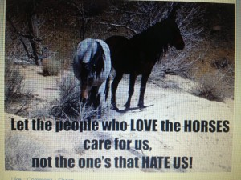
blm.gov/nv/st/en/prog/wh_b/adoptions.html
--
Check out our television show;
https://www.youtube.com/watch?v=KKdY2h5l8k4&feature=share
BUY A BOOK & HELP A HORSE-check it out!!!
http://www.leruepress.com/FinalBreath.htm
WWW.WynemaRanch.com

