Radio Program re: (NV) Wild Horse Issues. Wednesdays 11AM- Noon PST.
July 29th, 2015 (notes)
americamatters.us/shows/mustang-matters/
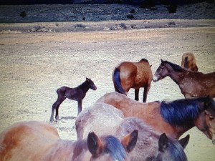
also http://renegaderadio.org/ (Reno, NV) or http://krng.streamon.fm/
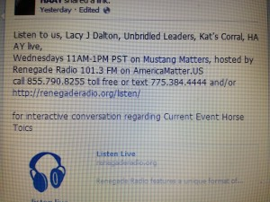
Call 855-790.8255 free or TEXT 775-384-4444 .
Hosted by,
lacyjdalton.com/ – Country Guitarist and Singer, 775.847.7322 founder of letemrun.com/
plus
Eddie Floyd, Host, Reporter, P.I.O., Fox News Radio- {NEVADA MATTERS INC. (Founder) -}
as well as wynemaranch.com/mustang-matters.html
and
also
Dee Gregory (rock & roll hall of fame MC) also on behalf of letemrun.com/
---------
Notes by,
haay.org/ - Helping Animals and Yourself
haay.org/news-mustangmatters-us/
July 29th, 2015
---
To audio archive Mustang Matters (alphabetized) radio shows, go to http://americamatters.us/show-archives/ and
all written briefs see haay.org/news-archived-radio-shows/
previous: Haay RR News May 6 2015, Haay RR News April 29 2015, Haay RR News April 22 2015 Haay RR News April 15 2015....
Opening music...—
--
Dee Gregory introduces Lacy J Dalton
Lacy J Dalton thanks Dee Gregory.
----
Caller:
Julie from Steiter.lites reflector thanks Palomino for her help getting the information out.
Julie describes the reflector on the hwy and the eligible funding (hazard elimination fund). Easiest and most economical
Julie Keller Streiter.lites (Facebook).
Ancient Greeks to Mark Twain to Winston Churchill, “The outside of a horse is good for the inside of a Man”.
Lacy describes Palomino and her Foal rescuing efforts
--
She could run- about survival of the spirit—wrote about Ruffy a winning Race Horse who (has accident/ run into by another horse and it breaks her leg. Doesn’t feel the medicine and notices, petting and loving and opening to heaven and could run, run, run…-
---
Lacy describes- Seven more little babies we were not expecting – (in a rescue efforet) and Palomino needs some Panels.
.----
John a horse fairier-
has a question about two clubbed feet (two front) first have to absecess & thruss (fungal infection in soft tissue- iodine, bleach, coppertox, are old remedies)
Frog the pump is the center of hoove and it pumps the blood up the leg.
Lacy asks if frog ok to trim?
Depends on the health situation and environment: dry temperatiures not so much and wet or stall/manure situations, yes maybe so.
The mustang with clubbed feet is totally wild—and even at a fast walk she got away from us, don’t want to push her and we’ll food trap her so it’s not so traumatizing. We’ll do this slow and easy.
Founder is a Fever inside the hoof, everything gets pushed out, and cracks the hoof, etc…—big problems
Different ways to treat this: John thinks take off the shoes, take off the man made materials and trim their hoof back to a comfortable level and put them in a medium ground surface let it breath- grow out and re-evaluate hoof thru out.
---
Justin Delanee
John Delanee- Fairier.
– Jim Rigger

Madory from Wynema Ranch. Horse Trainer.
Lacy comments about horse feet and asks what is the most important to know about a horses feet?
Madory comments always look
Coffin bone straight down, no it’s pretty much close to done. They go into medical detail about why…
Worry more about angle of feet than if one leg is longer than another.
What is club foot? Completely upright or on toes- like a ballerina if past 63 degree angle may get real painful – horses are amazing they are adaptable but the problem may kill them so is best to fix.
Caught horse between two panels- amputated just after the knuckle,
Evelyn Roberts
Shari Floyd—little princess. How did that work out for you today- Dee asks?

Shari got her feet fixed.
--
Don’t work wild horse in a round pen. Don’ do butts. Millions of ways to train a horse.
---
Jennifer burten nv broadcaster hall of fame.
---
Shari would be real happy to show you around, call me 775.842.6229. eed a water pump- we have a generator to pump water laughs not feeding the horses gasoline- coast about $4K see website for fundraiser.

August Bluegrass Festival of Brauers Manssion – 2:15PM Lacy 775.742.5338
--
John talks about ca

--
THANK YOU FOR YOUR INTEREST AND SUPPORT! HAVE A BEAUTIFUL BLESSED DAY!
---
please remember:
BLM HORSE AUCTION –
BLM/ CARSON CITY PRISON
blm.gov/nv/st/en/prog/wh_b/adoptions.html
&
News and voting:
http://www.wildhorsepreservation.org/
info
Destination Locations
http://www.haay.org/adventure-eco-horse-tour/
when visiting the N. Lake Tahoe area this haay.org/adventure-n-lake-tahoe-historic-cabin proceeds support Charitable Wild Horse Organizations
in the surrounding areas. Watch for details, most sponsors share proceeds which go to support the wild horse advocates.
---
Notes presented to you by,
haay.org/ - Helping Animals and Yourself (home page).
haay.org/news-mustangmatters-us/
---
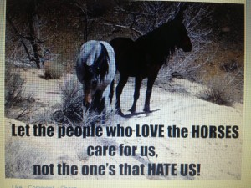
blm.gov/nv/st/en/prog/wh_b/adoptions.html
--
Check out our television show;
https://www.youtube.com/watch?v=KKdY2h5l8k4&feature=share
BUY A BOOK & HELP A HORSE-check it out!!!
http://www.leruepress.com/FinalBreath.htm
WWW.WynemaRanch.com

