Radio Program re: (NV) Wild Horse Issues. Wednesdays 11AM- Noon PST.
July 15, 2015 (notes)
americamatters.us/shows/mustang-matters/
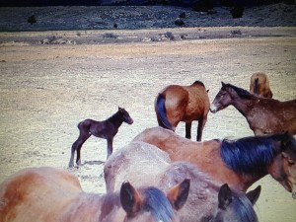
also http://renegaderadio.org/ (Reno, NV) or http://krng.streamon.fm/
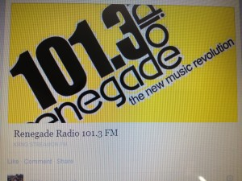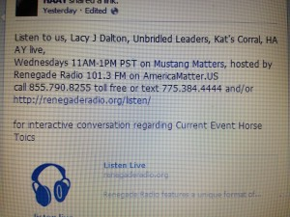
Call 855-790.8255 free or TEXT 775-384-4444 .
Hosted by,
lacyjdalton.com/ – Country Guitarist and Singer, 775.847.7322 founder of letemrun.com/
plus
Eddie Floyd, Host, Reporter, P.I.O., Fox News Radio- {NEVADA MATTERS INC. (Founder) -}
as well as wynemaranch.com/mustang-matters.html
and
also
Dee Gregory (rock & roll hall of fame MC) also on behalf of letemrun.com/
---------
Notes by,
haay.org/ - Helping Animals and Yourself
haay.org/news-mustangmatters-us/
July 15th , 2015
---
To audio archive Mustang Matters (alphabetized) radio shows, go to http://americamatters.us/show-archives/ and
all written briefs see haay.org/news-archived-radio-shows/
previous: Haay RR News May 6 2015, Haay RR News April 29 2015, Haay RR News April 22 2015 Haay RR News April 15 2015....
Opening music...—
--
Dee Gregory introduces Lacy J Dalton
Lacy J Dalton thanks Dee Gregory.
----
Wonderful Special Guest Panel:
Lacy comments on the over all health of the horses in Montana. Grass up to their elbows.
---
Cattle Drive and concert was the closest thing to a vacation Lacy has had she said in about 20 years.
Introductions:
Carol Nicholson and other guests—
Carol is on her lunch break, Jim giving up his seat so Carol can share her information before she has to go back, since she is on her lunch hour.
Mustangs are doing well, thanks to Shari.

Lacy describes the NV State tried to prosecute her. She will try to Dept of Agriculture article where they were vindicated. Sharon wrote a beautiful article.
July 24th, 25th, 26th weekend Art Show, complimentary 10AM-4PM Wilber May Museaum
775.785.8961 reception at 6PM-10/11Pm for a tribute and showcase Lacy J Dalton for her Amazing work over the last two decades for the Wild Horses, 77843.3900 facebook.com/NevadaFineArtShow
---
Dee and Lacy tease about Men Welding Fire, tri-tip, pesto chicken, pulled pork… Wild Horse Wines, Southern Wine & Spirits donating Dark Horse Wine-
Great Basin Brewing Company, serving an Ale.
--
Connie Carlson at Wild Horse Saloon Inn
Blood Coffee
Model Dairy for the Ice Cream—
Bistro in the Atlantis/ gives a $1000 gift.
Legends at $100
Local AT&T
---
Sharron DeCarlo
The Biggest Publisher - Horse Tales
----
Caller-
Julie Keller, would wait- welcome back Dee. How did your surgery go? He is re-wired now, has a new battery. His whole left side is all hacked up. Lacy says the girls dig scars—
Horse Tales any feed and western store, largest equine events: dressage, rodeo, $25 a year will send right to your address. 775.265.7137 - cell 775.790.1880.
--
Shari with the Ranch Report,
my new helper Madory is busy with horses. Moving them all around, and using that big area to turn them out.
Madory what is going on out there- 707.479.8031
Evelyn Rogers with Merchandise for Let “Em Run 775.742.3558
--Thank you Craig the radio Engineer--
---
Call in to Mustang Matters any time at
--
Great panel:
Julie Keller
Head Trainer at Wynema Ranch,
Evelyn- Dalton Girls
Jim Rigger
Sharron DeCarlo.
---
announces sponsors
Rogers Feed & Supply- http://www.rogerscowboysupply.com/
Ty Rogers - http://www.desertsagebeadart.com/
One stop feed store - http://www.1stopranchandfeed.com/
James Clark Hay & Livestock, 7800 North Virginia St., Reno, NV 89506 - Phone: (775) 225-2277
---
Julie Keller-
Petition is a great idea- 364 signatures and over 105 on another- make sure you get hooked up with Palomino.
Petition Change.org Streiter-lite
What are they signing up for? Streiter-lite Hwy warning reflective light street. Side of the hwy, so when headlights hit it creates complete fence appearance coverage-
Reno Gazette and Nevada Appeal has archive.
Horse Tales Northern Nevada and Northern California.
775.265.
Horsetalesltd.com
Will James society may very well be one of the first advocates and one of the original writers-
Will James.org tickets September 19th Dangherb Home in Minden- Historical ranch/Museum- fun and adventurous. Harold Roy Miller
10 AM - evening
Is Richard Allion there?/ nope not this event – he has been at many others and we love him…
---
Madory, working at Wynema and getting organized, hoping to do some confidence building workshops soon/ no date set but will announce
---
Madory & Sharron will also share information to help promote a training workshop
827.8900. -- 844.790.8255
---
dee@lacyjdaton.com
--
Wildhormanship.com Madory
---
A BLM horse that Carol Nicholson’s adopted Coliced last weekend- what is the first thing that you do: assess it, then Vanamine (sp?) relaxes gas, from an old show/M.A.S.H. has an episode where they flush him from the backside. Or there is a oiling—put a big tube down there throat and then something that looks like Crisco flushes their blockage.
--
Jim’s grandson turned 9 years in Gilroy. The family are now then coming up for Jim’s (grandfather) birthday next month, they plan to visit Trigger at Wynema Ranch –
the panel then teased about all the (pretend- attack) animals, chickens, goats, pigs, donkey, horses- etc… they teased how Dalton Girls bunkhouse they may even dance for your if you stay and how Eddie will charboil the hotdogs….
--
Sharron DeCarlo Horse Tales- had a distress call in there is a turn of events that has happened and neighbors have stepped up, we have hay coming in, we have people coming to help land owner maintain as they are recovering from their surgeries.
Little Washoe Lake – people like them out there on the East Side, so they are watching out for them as best as they can right now.
Love to get good news!!!
She comes to every event and she buys a piece of merchandice and also buys her ticket – when she
---

----
THANK YOU FOR YOUR INTEREST AND SUPPORT! HAVE A BEAUTIFUL BLESSED DAY!
---
please remember:
BLM HORSE AUCTION –
BLM/ CARSON CITY PRISON
blm.gov/nv/st/en/prog/wh_b/adoptions.html
&
News and voting:
http://www.wildhorsepreservation.org/
info
Destination Locations
http://www.haay.org/adventure-eco-horse-tour/
when visiting the N. Lake Tahoe area this haay.org/adventure-n-lake-tahoe-historic-cabin proceeds support Charitable Wild Horse Organizations
in the surrounding areas. Watch for details, most sponsors share proceeds which go to support the wild horse advocates.
---
Notes presented to you by,
haay.org/ - Helping Animals and Yourself (home page).
haay.org/news-mustangmatters-us/
---
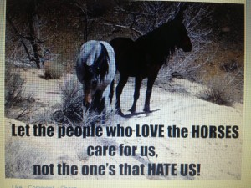
blm.gov/nv/st/en/prog/wh_b/adoptions.html
--
Check out our television show;
https://www.youtube.com/watch?v=KKdY2h5l8k4&feature=share
BUY A BOOK & HELP A HORSE-check it out!!!
http://www.leruepress.com/FinalBreath.htm
WWW.WynemaRanch.com

