Radio Program re: (NV) Wild Horse Issues. Wednesdays 11AM- Noon PST.
July 1, 2015 (notes)
americamatters.us/shows/mustang-matters/
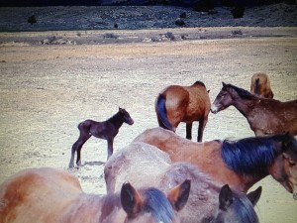
also http://renegaderadio.org/ (Reno, NV) or http://krng.streamon.fm/
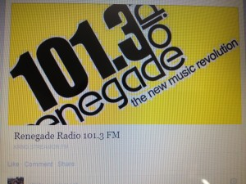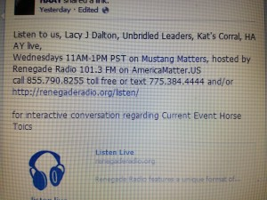
Call 855-790.8255 free or TEXT 775-384-4444 .
Hosted by,
lacyjdalton.com/ – Country Guitarist and Singer, 775.847.7322 founder of letemrun.com/
plus
Eddie Floyd, Host, Reporter, P.I.O., Fox News Radio- {NEVADA MATTERS INC. (Founder) -}
as well as wynemaranch.com/mustang-matters.html
and
also
Dee Gregory (rock & roll hall of fame MC) also on behalf of letemrun.com/
---------
Notes by,
haay.org/ - Helping Animals and Yourself
haay.org/news-mustangmatters-us/
July 1st , 2015
---
To audio archive Mustang Matters (alphabetized) radio shows, go to http://americamatters.us/show-archives/ and
all written briefs see haay.org/news-archived-radio-shows/
previous: Haay RR News May 6 2015, Haay RR News April 29 2015, Haay RR News April 22 2015 Haay RR News April 15 2015....
Opening music...—
--
Dee Gregory introduces Lacy J Dalton
Lacy J Dalton thanks Dee Gregory.
----
Wonderful Special Guest Panel:
---
Eddie Floyd introduces Madory
Dusty would walk out.

Lateral reflection not pulling horse around to elbow, pull lead rope and not have tension and flex from head to elbow- pick up a reign. Much easier to explain in person- so we welcome all to come and talk to me.
--
Julie Keller- touches base with the / Julie the horses are in our fencing could you come and get them, never looked them in the eye & turn around and act like I had something in my hand and they woud follow me out. –
Eddie says Pied Piper of wild Horses – he also thinks because you did not approach them with aggression and they were curious.
Julie and Greg Downer had been working hard with NDot & Lobbying for 50East and high Strike area. Up to 260 signatures on the petition.
---
Madory- LA, Hawaii, Napa (clorified pony rides to tourists/ dude string work – she would really see the things going on with the horses. They would numb up, they were bord, the were –
Learing how to ride- how to use you pelvise, your core body and strong—not just sitting on them and going for a ride. The horses really want to be obedient but want to ride a horse that is responsive and soft- need to work at that

Seminars:
Mustang Matters- 844.790.8255.
Abigail—Abby Ohio, says hello and official horse whisperer/ she loves horses for a long time. Talks about a trail ride and a run- back ground in horsemanship.
Madory says he was probably Barn Sour- He wanted to go home. Their training is not really training. Probably just to go home and get some rest. Don’t pull on both reigns. Just pull one reign in
Be safe in Vermillion, OH
707.479.8031 Madory
---
Lacy J and Dee are in Billings Montana- Mur Hager’s son and tow or three others and filming for TV.
775.742.5338.
---
Shari Wynema ranch 775.842.6229 (texting is best way to go).
---
Mustang Matters is a a radio show and an e- publication
---
announces sponsors
Rogers Feed & Supply- http://www.rogerscowboysupply.com/
Ty Rogers - http://www.desertsagebeadart.com/
One stop feed store - http://www.1stopranchandfeed.com/
James Clark Hay & Livestock, 7800 North Virginia St., Reno, NV 89506 - Phone: (775) 225-2277
---
Caller :
www.wildhorseclassrooms.com
Mustang Megan Dixen
Campaign for the education: stables, classrooms,
----
Madory—
Seminar no date set yet
Write for horse magazines: cowgirl magazine. Wildhorsemaship.com (has links)
Kelly Rush is putting you on the cover of the e-publication.
Get involved with up, visit Wynema Ranch. Stay at the Bunk house, Visit the Wild Horses, Have a BBQ, watch or clinic with Madory.
----

Harold in Henderson NV- do you have a favorite? Geldings or Mare? Gelding sometimes a little easier—she wouldn’t trade her Penny for the world.
--
Sarah in Sacramento – have you ever trained a Stallion and would you? Madory: I have not and prob would not?
--
Gelding is a Stallion that has been neutered.
--
Harriot wrote in what is an age of a horse’s life, Big question: mid 20’s.
Jennifer a donkey is in her 30’s, who lives a Wynema.
--
Donkey, Mule or Horse which is smarter? Shari says Donkey. Eddie says Mule is smarter than a Horse will not ride into fire.
---
Carol Nicholson 23 days from today the Nevada Fine Show –
Atlantis Casino resort and spa gave a $1000, wild horse wine chardonnay and cab
7758433900. RSVP needed $25 also online
July 24th, 25th, 26th Reception Hall Wilbert
--
Foresight Wellness offering HippoTherapy (Horse Therapy) special needs article was about special Olympics – earlier
---
844.790. 8255 Mustang Matters
---
Mustang Advocates all have been coming together. Some of the advocacy groups just want them to be free. Other advocacy groups would love that too but know the future is not proving this to be so, Sanctuaries area fabulous start; they animals can live their life out, people can come and enjoy them, there is potential for adoption making room for others, there are therapy connections, etc…
--
7074798031 Madory
Evelyn 7425338
Shari 775.842.6229 & visit
Kelly Rush--- Kelly@amaricamatters.us
----
THANK YOU FOR YOUR INTEREST AND SUPPORT! HAVE A BEAUTIFUL BLESSED DAY!
---
please remember:
BLM HORSE AUCTION –
BLM/ CARSON CITY PRISON
blm.gov/nv/st/en/prog/wh_b/adoptions.html
&
News and voting:
http://www.wildhorsepreservation.org/
info
Destination Locations
http://www.haay.org/adventure-eco-horse-tour/
when visiting the N. Lake Tahoe area this haay.org/adventure-n-lake-tahoe-historic-cabin proceeds support Charitable Wild Horse Organizations
in the surrounding areas. Watch for details, most sponsors share proceeds which go to support the wild horse advocates.
---
Notes presented to you by,
haay.org/ - Helping Animals and Yourself (home page).
haay.org/news-mustangmatters-us/
---
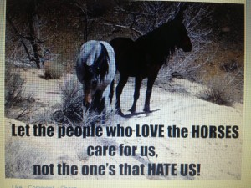
blm.gov/nv/st/en/prog/wh_b/adoptions.html
--
Check out our television show;
https://www.youtube.com/watch?v=KKdY2h5l8k4&feature=share
BUY A BOOK & HELP A HORSE-check it out!!!
http://www.leruepress.com/FinalBreath.htm
WWW.WynemaRanch.com

