Radio Program re: (NV) Wild Horse Issues. Wednesdays 11AM- Noon PST.
APRIL 22, 2015 (notes)
americamatters.us/shows/mustang-matters/
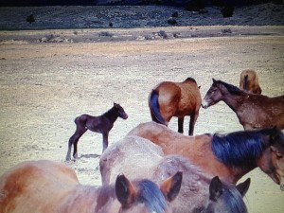
also http://renegaderadio.org/ (Reno, NV) or http://krng.streamon.fm/
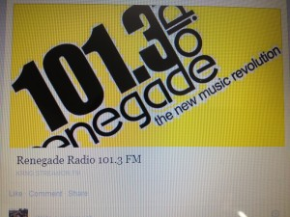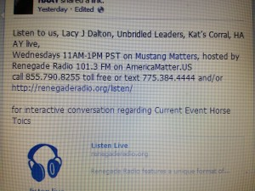
Call 855-790.8255 free or TEXT 775-384-4444 .
Hosted by,
lacyjdalton.com/ – Country Guitarist and Singer, 775.847.7322 founder of letemrun.com/
and
Eddie Floyd, Host, Reporter, P.I.O., Fox News Radio- {NEVADA MATTERS INC. (Founder) -}
Please JOIN IN live: (see all above) as well as wynemaranch.com/mustang-matters.html
& Wife:
Shari Floyd from Wynema Ranch
wynemaranch.com/shari-floyd.html
telephone 775.842.6229.
--
Lacy & Eddie are joined by Karen Veneis & Evelyn Roberts.
{Karen Vineis , 775.741.4771, wynemaranch.com/karen-vineis.html
Kvineis@hotmail.com and Karen@wildhorsepreservation.org
&
letemrun.com/ , sales, Evelyn Roberts 775.742.5338}.
---
Special Guest:
Kathy
Sierra Nevada Horses & Hero’s
For Wounded Veterans
Looking for Trainers striving for PATH International Certification www.pathintl.org/
Certified Trainers: Children, Veterans,
They are the ones who set Set Safety Standards.
ZBar Zippidezoda- Zippy the Zebra (9 yrs old).
---
James Forsesight, Hippotherapy is coming to Wynema Ranch
---
Panel teases and talks about Zebra & Horse crossings and thoughts.
---
Callers:
Palomino Honeybandit Armstrong
chillypepper.weebly.com/
Palomino describes paying for the babies- about $80. If they are not sold- get hit in head with hammer &/or fed to someone’s dog.
Lacy describes how that she is disappointed in
4 mares had babies- someone was trying to buy them- were not accepted and the babies were taken around back to the dumpster & struck on the head.
Palomino has four babies in her nursery.
Maverick has soooo much stress loss his hair. His body cannot regulate itself. People are sending blankets (Palomino’s washing machine is broken).
Getting closer to Trailer Fund at

http://www.youcaring.com/emergency-fundraiser/help-matt-palomino-save-orphan-foals-from-slaughter/332653

Over 1400 miles round trip around 35 degrees in trailer- 16 hours round trip.
Lacy rants on how terrible the treatment is for the wild Mustangs, then describes how she hopes our community can turn this around and praises the people
Furisen (?) is tried & trued balm for horses
Please donate and
Share This Fundraiser
See also for more details: haay.org/mustang-foal-baby-horse-rescuers/
--
Shari
says feed bill is about $6K a month for 125 head of Mustangs.
---
Kathy (guest speaker)
Galas Z Bar
All Veterans are welcome
Purposely chose the name - Sierra Nevada Horses & Hero’s
Healing Happens
---
D Gregory announces:
Comedy Stand Up - First Annual Event - Stand up for Horses –
www.standupforhorses.com
May 30th at Airport Plaza Hotel, in Reno
Cat Simmons headlining, perform & comedians.
Advance $15- for two$25- $20 at door
---
Genoa Cowboy Festival
May 2nd in
Evelyn will have merchandise
--
Mary Alice-
Prenatal brain damage 16 yr old.
Routine, Calmness,
Zebra, donkey, Mini, chickens,
Lots of synergy! Prof Ass Therapeutic Horsemanship
½ quarter & ½ Mustang is Mary Alice’s daughters horse & it a love.
---
Evelyn:
Hats
Genoa Cowboy Festival
---
Lacy comments:
Gene & Evelyn raise money for Let ‘Em Run for various things like hay, spay & neutering
--
Caller:
Bonnie Matton International Rally 4/25/15 10AM-12noon
775.720.5134
Denver 170 has biggest number, UK, Australia, and more
Tour Group- Sunnyboys tours, see Tina.
775.200.5025 and gives wonderful tours for seeing the wild horses
Signs are welcome- the more the merrier.
--
Karen comments:
We have two herds of Horses Roans & Paints 14 of them.
Roho & Wayland
I80 East on the highway, chocolate color horses.
--
Wynema Ranch
Silver Legacy and Karen Vineis also does horse tours.

Trainers in LA.
--
The 80% of prisoners who do the Wild Horse Prison Program do not wind up back in jail.
--
Shari-
Feeds 16 bails of hay a day. 130 horses, the currently have about 6 days worth of food.
--
D Gregory
Please donate
--
Lacy thanks her special guest for being at the radio
Kath Gallis & Mary Alice

---
Panel discusses Gelding (neutering horses) and how many horses they have the desperation for hay.
Please Donate, Adopt, Sponsor, Visit, etc…
--
Spirit of the Warrior lives on at the Hero’s
Thank you Kathy for being here. Kathy is dreaming about future concepts of possibilities of people who have been through the program and aspire to own their own horses- maybe that could happen; they are in this for the long hall. If
775.741.9203 in Spanish Springs- Therapy Program, geographically is underserved. Healing Happens.
--
Horses & Hero’s,
Alina is 16 & has bee working with horses snc eshe was very young-
Synergy 4H, working with the children, LueAnn: sidewalker, confidence, balance, core, semi retired physical trainer- taught pilates for core balance
Working on synergy & fundraising
Gofundme- KZL130 events may 4-
St.Mary’s fitness challenge. Daily exercise & end of the time is a free massage.
June – fire it up BBQ, poerty, boyscouts,
July 27th ACE’s Horses & Hero’s night
775. 741 .9203
Fall Galla dinner to be announced
Read Vision Statement from the
--
Eddie comments:
Connie McMullen senior spectrum
---
Panel discusses Veterans and head trauma, either PSD &/or physical trauma (
---
Karen,
Great Basic Mustang Trainers
--
D Gregory announces sponsors:
Ty Rogers - http://www.desertsagebeadart.com/
One stop feed store - http://www.1stopranchandfeed.com/
James Clark Hay & Livestock, 7800 North Virginia St., Reno, NV 89506 - Phone: (775) 225-2277

